Web design style guide

Brand: construction company

Purpose of web presence : marketing tool , streamline business processes

Target audience : Individuals

Logo (Deisgned from Adobe illustrator )

Global Color Palette

Navigation bar (header and footer ): 

Typography

font-family: "Open Sans", sans-serif

Layout and

Icon style (Font awesome )

Background images

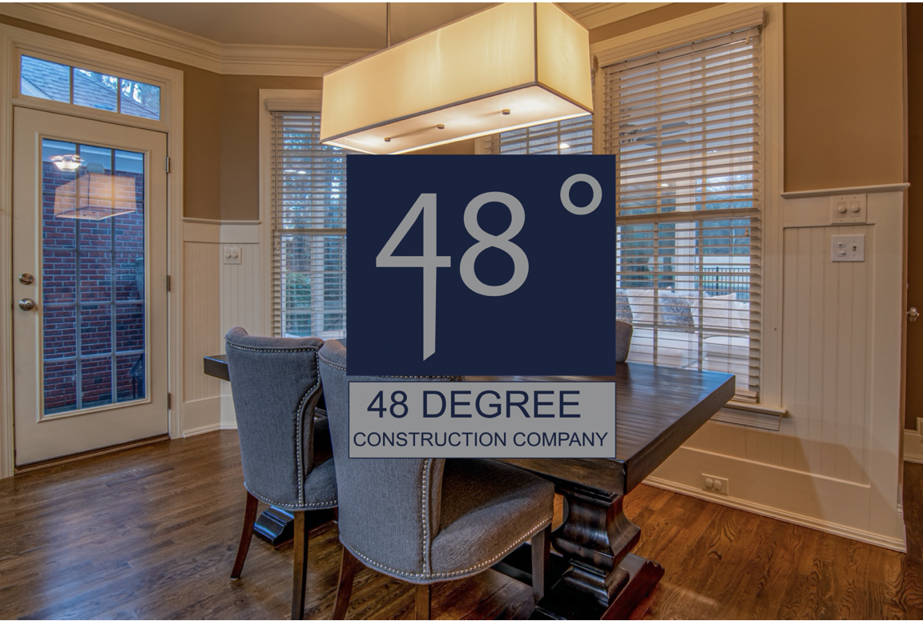

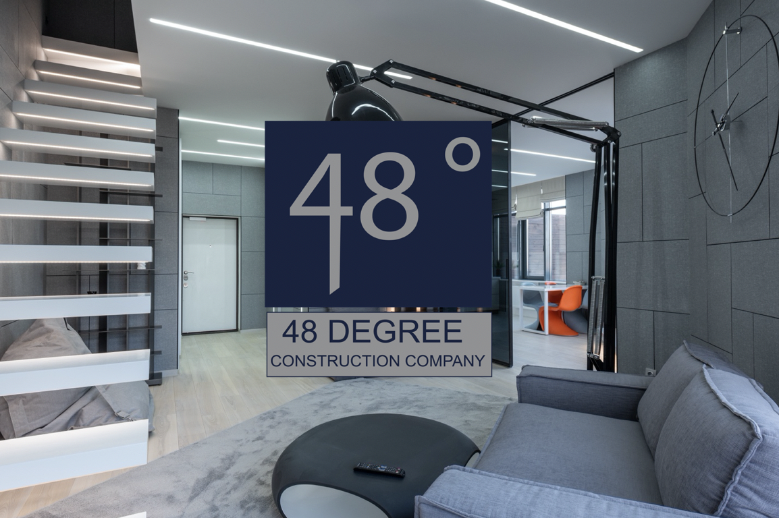

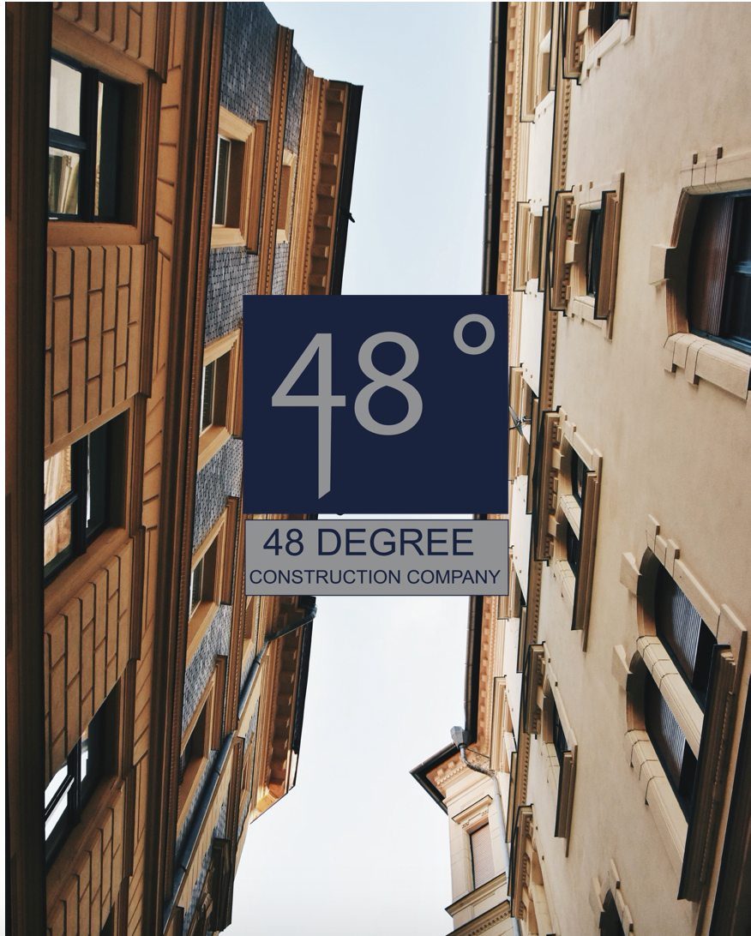

Background image